**Team 3**

**Delivered ✅**

**Software Requirements Specification for Online Restaurant System**

**Version 1.0**

Chrystal Mingo

Marina Skachko

Maya Dara Sofia Pasiliao

Mayra Vazquez-Sanchez

**Revision History**

|  |  |  |  |
| --- | --- | --- | --- |
| **Date** | **Version** | **Description** | **Author** |
| 11/04/2019 | 1.0 | Initial plan. | Team 3 |
|  |  |  |  |
|  |  |  |  |
|  |  |  |  |

**Table of Contents**

1. Introduction 4
   1. Purpose 4
   2. Scope 4
   3. Definitions, Acronyms, and Abbreviations 4
   4. References 4
   5. Overview 4
2. Overall Description 4
   1. Use-Case Model Survey 5
   2. Assumptions and Dependencies 5
3. Specific Requirements 5
   1. Use-Case Reports 5
   2. Supplementary Requirements 5
4. Supporting Information 5

**Software Requirements Specification**

# Introduction

*Delivered* **✅** is a multi-user system built for managers, salespeople, cooks, delivery people, and customers of the local restaurant scene to facilitate their restaurant activities. This is achieved by creating an appealing and intuitive WebApp with efficient user experience by consolidating all user needs into one place. This will ultimately create a unified system for all participants in the restaurants’ business dealings.

## Purpose

The purpose of this document is to describe the features, subsystems, and constraints of *Delivered* **✅**. This document will outline who can interact with the system and how. It will also delineate all the aspects of the system - functional and non-functional.

## Scope

*Delivered* **✅** is a web application which simulates work of an online restaurant system. The purpose of this system is to ease restaurant management, facilitate communication between different types of users, and create a convenient and easy-to-use application for store personnel, delivery personnel, and restaurant customers.

The system includes three subsystems: store, delivery, and customer subsystems.

* *Store* subsystem - restaurant. Restaurant lists 3 different most relevant food choices based on the order history of the registered customers and VIPs, and top 3 most popular choices of the restaurant for visitors.

*Store* subsystem includes its own subsystems:

* *Managers/supervisors* subsystem allows managers of each store to decide commissions of salespeople dealing with supplies, cooks’ salaries and delivery people, handle complaints of customers, and keep track of loyal and blacklisted customers.
* *Salespeople* subsystem allows salespeople to deal with suppliers for the best food supplies with best prices.
* *Cooks* subsystem allows cooks to determine the supplies qualities, menus and prices of different food items.
* *Delivery* subsystem allows delivery people to bid on deliveries, decide routes to and from the restaurant to the customer, and evaluate customers.
* *Customers* subsystem allows customers to order, pay and evaluate food and delivery people. There are 3 types of customers for each store: visitors, registered customers and VIPs, who receive different prices—highest for visitors and lowest for VIPs. One customer can be a VIP for one store, while a visitor for another.

## Definitions, Acronyms, and Abbreviations

|  |  |
| --- | --- |
| **Abbreviation | Term** | **Definition** |
| API | Application Program Interface |
| Back-End | The term “back-end” means the server, application and database that work behind the scenes to deliver information to the user. |
| CSS | Cascading Style Sheet |
| ER Diagram | The ER or (Entity Relational Model) is a high-level conceptual data model diagram. |
| Front-End | The term “front-end” refers to the user interface. |
| GPS | Global Positioning System |
| HTML | Hyper-Text Markup Language |
| JavaScript | JavaScript is a programming language used primarily by Web browsers to create a dynamic and interactive experience for the user. |
| JSON | JavaScript Object Notation |
| Prototype | A first, typical or preliminary model of something, especially a machine, from which other forms are developed or copied. |
| RDBMS | Relational Database Management System |
| SQL | Scripted Query Language |
| Subsystem | Group of interconnected and interactive parts that performs an important job or task as a component of a larger system |
| Web App | A Web application (Web app) is an application program that is stored on a remote server and delivered over the Internet through a browser interface. |

## 

## References

*Classical and Object-Oriented Software Engineering*, 8th edition, Stephen R. Schach, McGraw-Hill, 2010

Dareal Allan B. Garcia (2016, March). *Cookies and Coffee Shop Customer Menu Management System Software Requirements Specification document.* Retrieved from <https://www.academia.edu/23305911/Software_Requirements_Specification_Restaurant_Menu_and_Ordering_System_Amiable_Aromas_Cookies_and_Coffee_Shop_Customer_Menu_Management_System_Software_Requirements_Specification_Document>

## Overview

This document is broken up into four sections. This first section contains information on how this document is organized, as well as supporting information such as definitions that will help with the understanding of our document.

The second section covers the main features of our product. Included are the use-case model, which includes the names and descriptions of the users, and the main features of our system. This section will also present any assumptions or dependencies.

The third section defines all of the product’s requirements. These include supplementary requirements that were not listed in section two. The use-case model is further defined through the use-case reports in this section.

Section four includes prototype pages for the flow of our main features.

# Overall Description

# This section provides a background for the technical requirements outlined in Section 3, and makes them easier to understand. This includes assumptions about *Delivered* ✅ users and app dependencies. Assumptions and dependencies are outlined for different categories of personnel and customers.

## Use-Case Model Survey

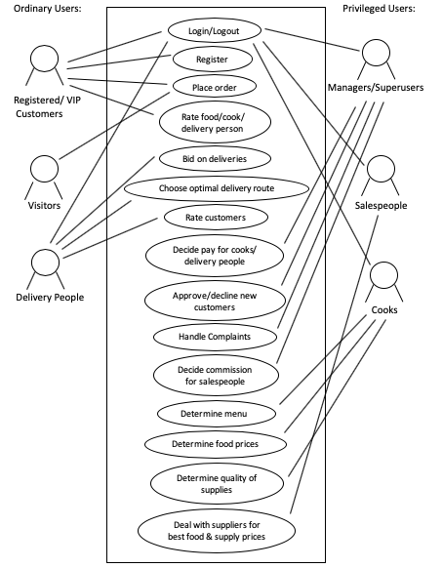

## Assumptions and Dependencies

General requirements for all users:

* Since the application is a web based application there is a need for the internet browser. It is assumed that the users have access to internet and any type of browser (Chrome, Mozilla Firefox, Microsoft Edge, Opera, Apple Safari, etc.).

It is also assumed that the user is familiar with an internet browser and knows how to use it.

Delivery subsystem requirements:

* It is assumed that the delivery people will have access to GPS service to find the shortest route and traffic on the roads.

Customer subsystem requirements:

* It is assumed that the customers who require use of the voice order feature will have a microphone to place voice-based orders.
* It is assumed that customer gives the app permission to use his/her location.

# Specific Requirements

## Use-Case Reports

All users have access to a log-in page that takes them to different screens based on their roles:

* Managers/Superusers

They have the most security privileges among the different types of users and oversees all business processes. They also have access to all other users’ financial information (salary, commissions, etc...).

* Salespeople

They have access to supplier screen that displays different suppliers and each supplier’s prices for each of their products.

* Cooks

They have access to menus (with ability to write menu items and prices) and to the salespeoples’ supplier screen to input how much of an ingredient they need.

* Delivery People

They have access to the deliveries screen, as well as a map that displays possible routes from restaurant to customer destination. They are also able to evaluate customers after a delivery is made.

* Customers

There are three types of customers: visitors, registered customers, and VIPs. Menu prices vary depending on customer type (VIP customers have lowest prices and visitors have highest prices).

ER diagram (without attributes):

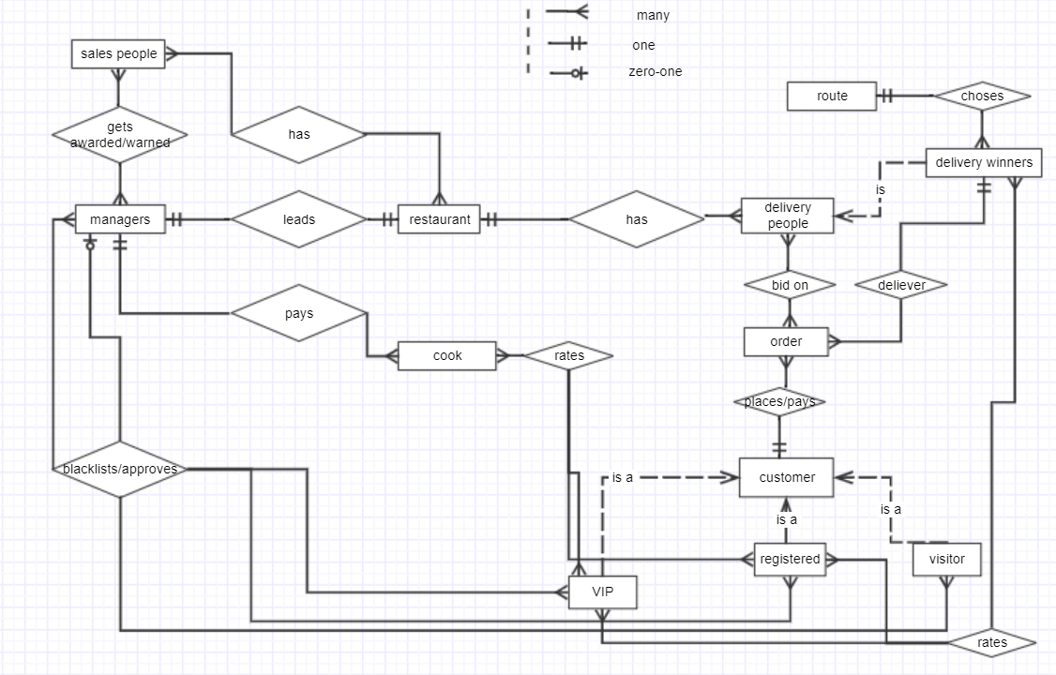

## Supplementary Requirements

* Customers will be able to see the status of his/her order on the progress bar. The bar will include following stages:
* order received
* in progress
* on the way
* delivered
* Any user will be able to reset forgotten or weak password using Twilio’s SMS two-factor authentication
* Data storing - either JSON or SQL
* Scheduling API for choosing optimal route
* Schedule - manager has access to all personnel’s schedules. Personnel can only see their own
* Chat for managers and personnel to discuss schedules

# 

# Supporting Information

For supporting information, we created the user-interface prototype for each user: Customers (Guest, VIP, Registered), Managers, Cooks, Salespeople, and Delivery people. We used the platform *figma* to create these prototypes. The prototypes are used as a basis to help develop page to page what each user will experience on *Delivered* **✅,** our online restaurant delivery app. These are all rough drafts, but help us consolidate how many pages we need to create and think about the user’s experience overall.

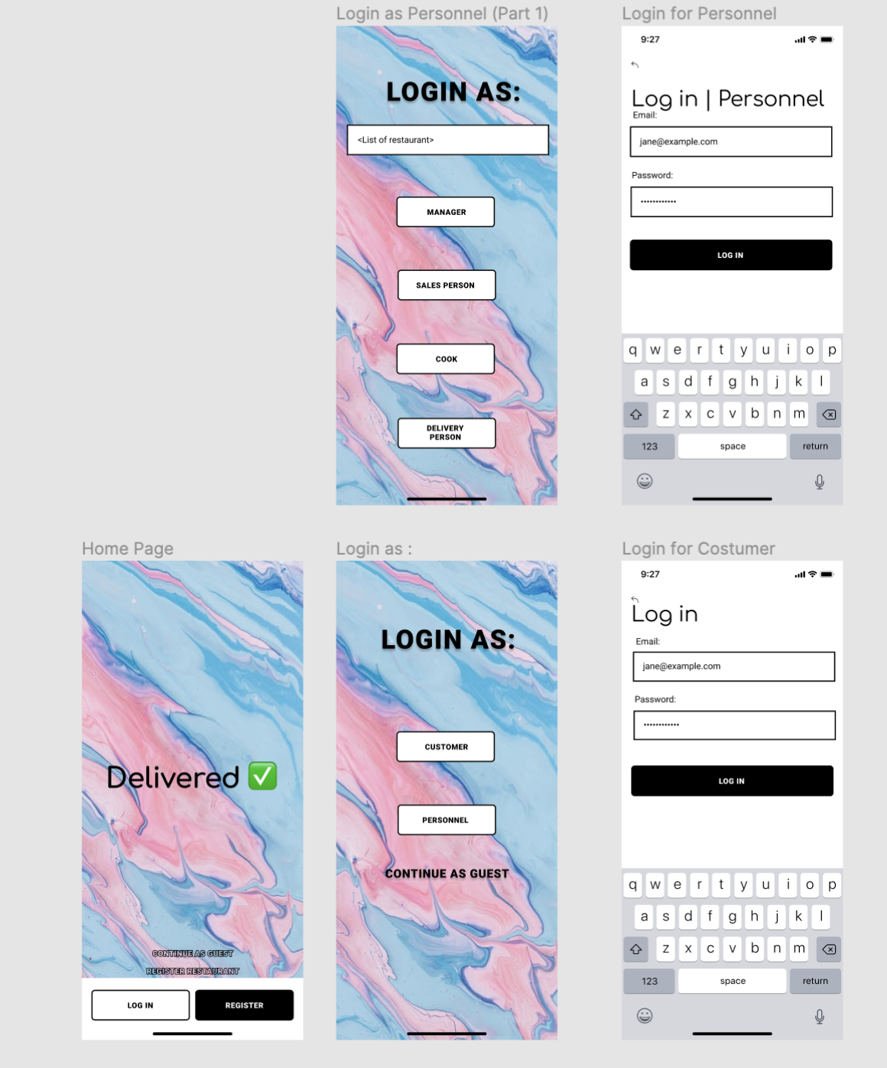**Login/Registration Page:**

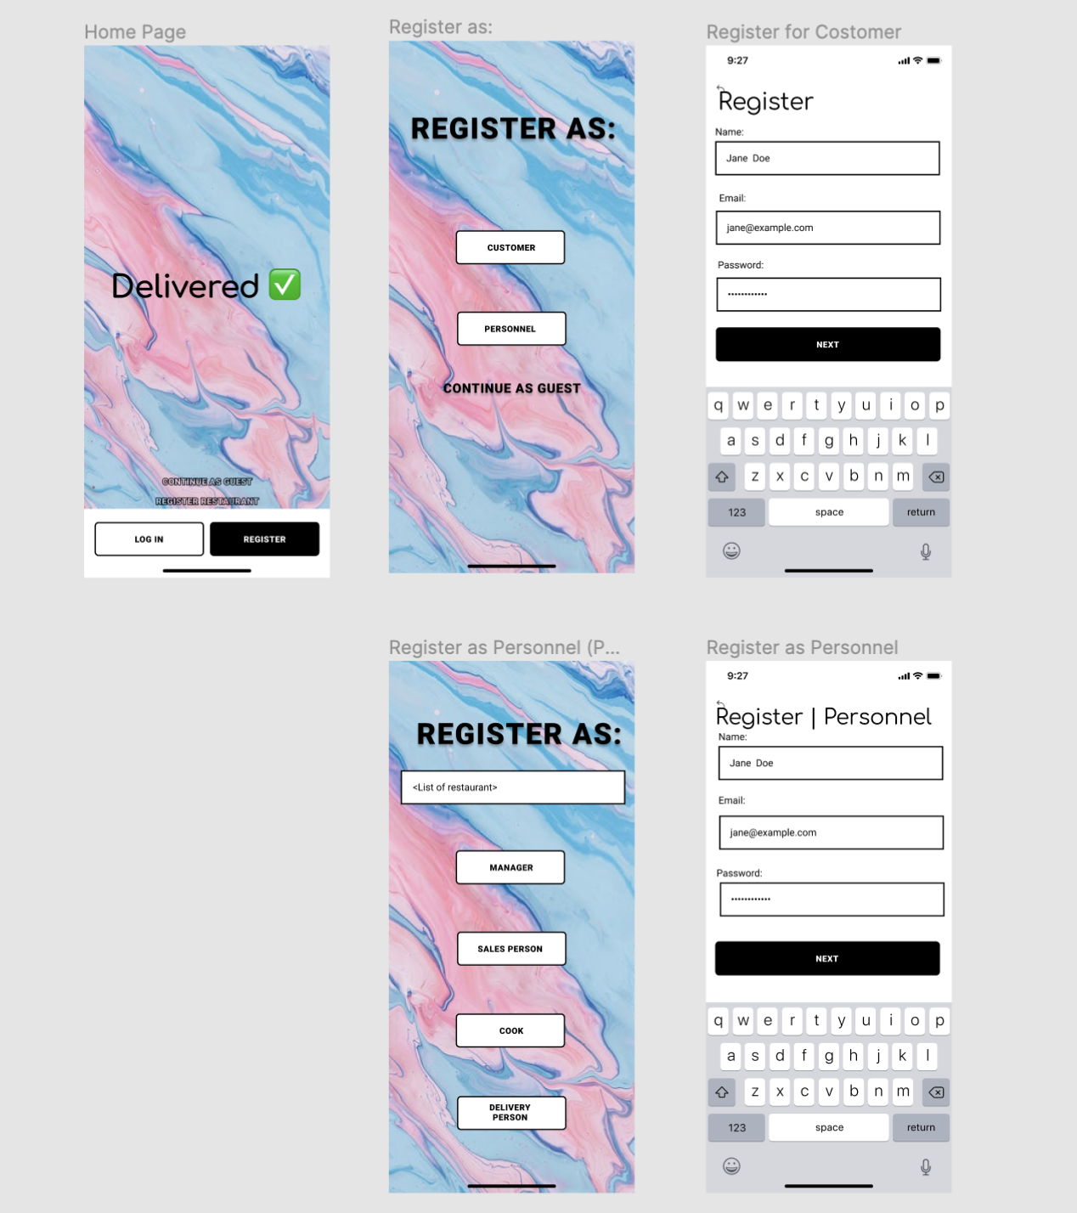

The login/ registration page is for all users. We decided to split the login and registration page into two groups: customer and personnel. Personnel represents the Manager, Salesperson, Cook, and Delivery Person. Customers can register or continue as a guest to order food from various restaurants. We also included a link for restaurants to be able to contact us if they would like to add their business to *Delivered* **✅.**

**User: Manager**

The manager can be considered the admin of the page. He or she is in charge of accepting or declining personnel, as well as customers. The manager is also in charge of paying/commissioning the employees. We added some features such as creating a chat between the personnel and manager. The manager is also able to see the schedules of each employee.

*This is the manager’s user-interface:*

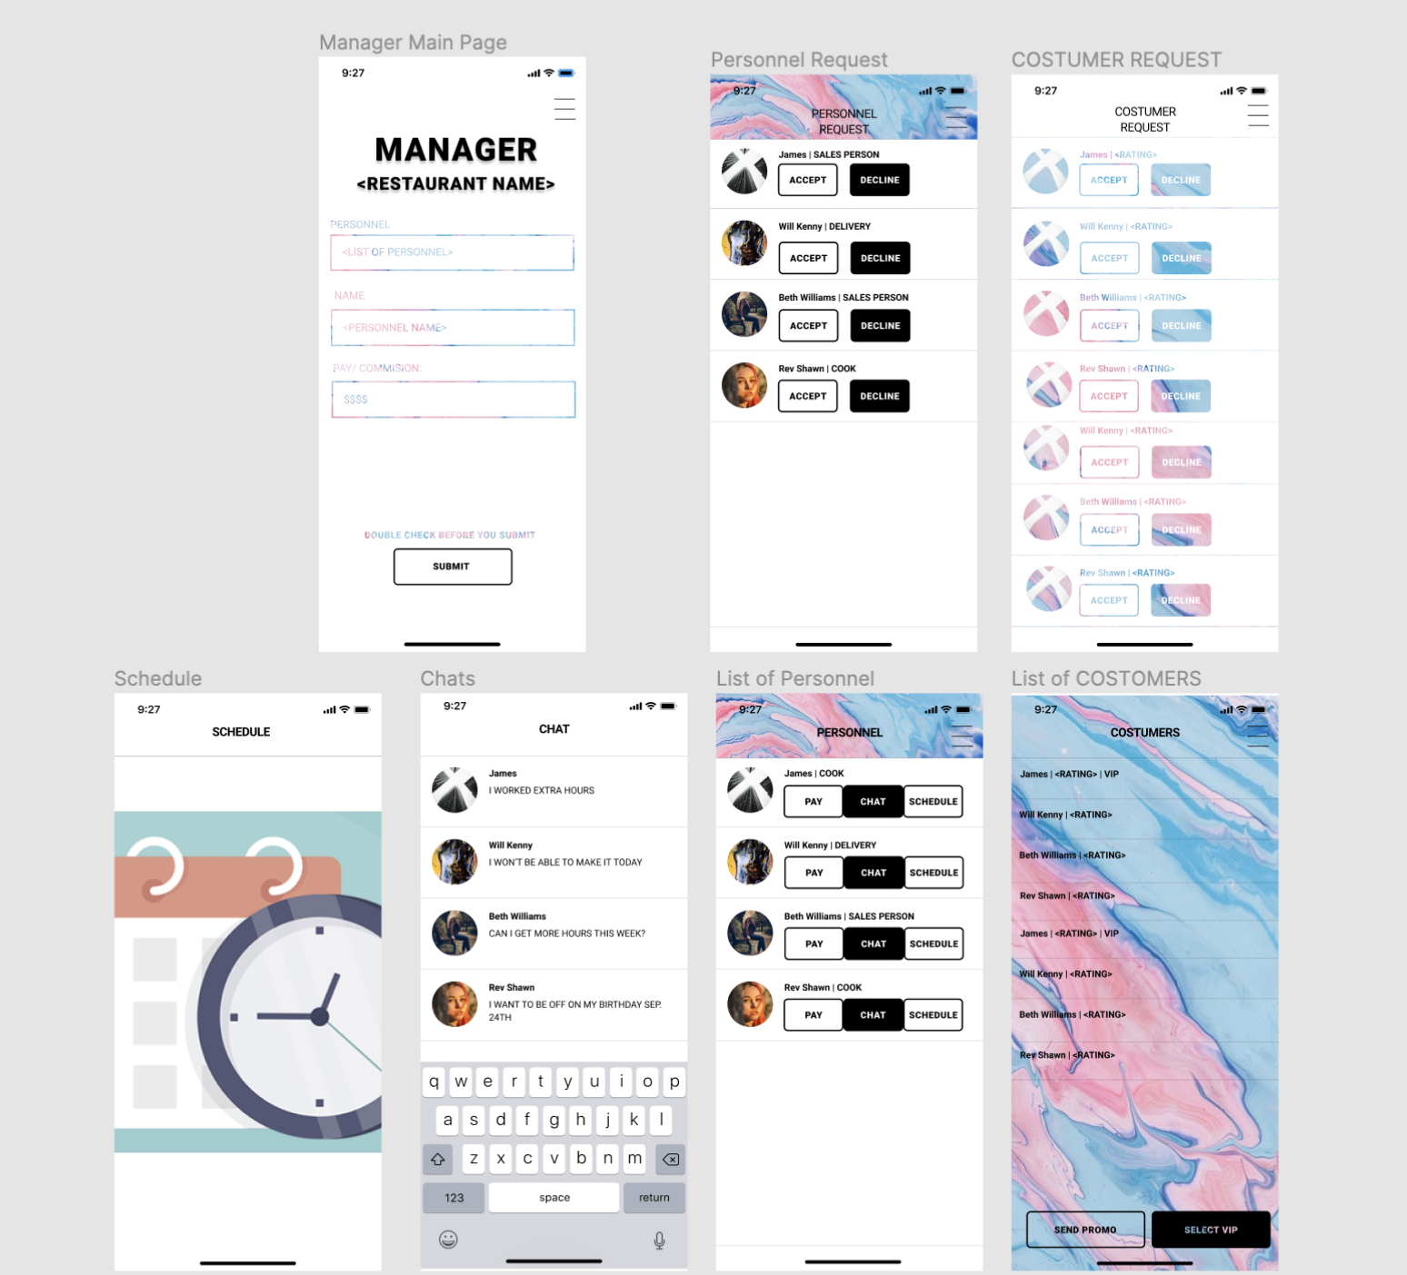

**User: Cook**

The cook is able to make the list of supplies they need, as well as make changes to the menu.

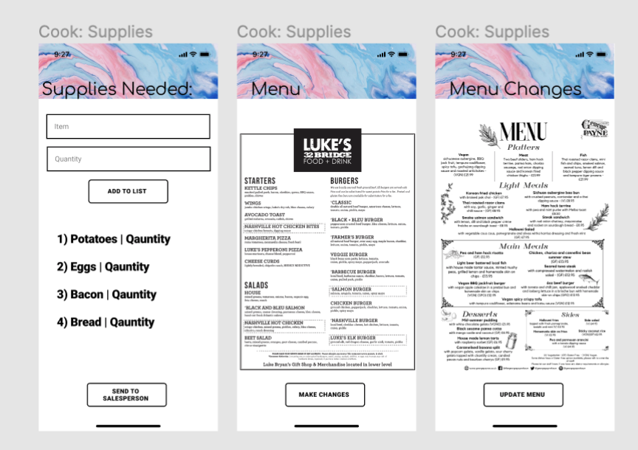

**User: Salesperson**

The Salesperson is able to see all the supplies the cook needs view their previous orders, search for supplies and filter by price, and can order supplies online to reach on time for the cooks.

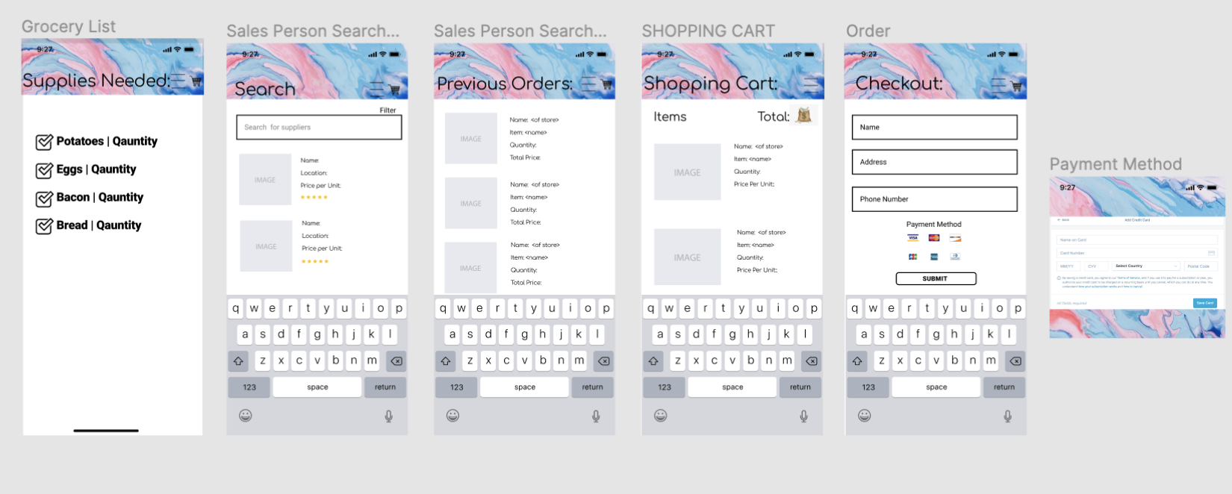

**User: Delivery Person**

The delivery person is able to bid on customers and see their ratings as well, while they’re bidding. This specific user is able to decide if they want to use google maps or waze to help them find the most optimal and time efficient route, to deliver to the customer in a speedy manner. The delivery person can also rate the costumer.

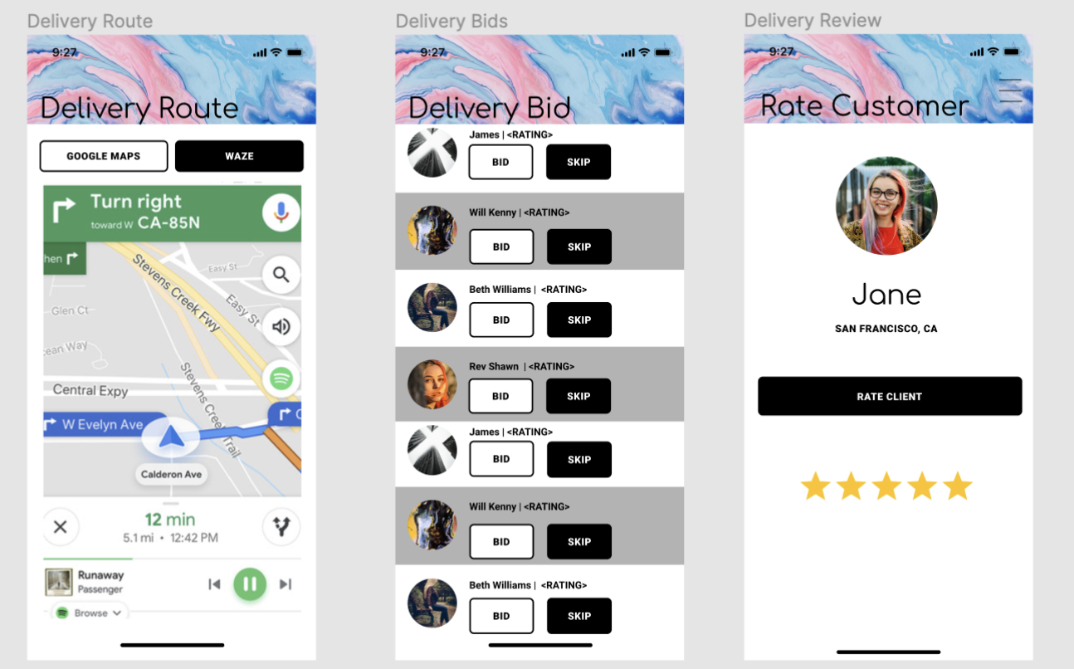

**User: Customer**

The user has multiple pages. Starting off with the discover page which showcases trendy restaurants nearby and displaying their cuisines. As you scroll down you see our “Food Heaven” this showcases delicious foods and when you hover over them you are able to see the restaurant that made the cuisine as well as the price. You can also view the full menu of the restaurant. The customers who are registered/VIP can post their food and give reviews on the food, cook and delivery l. They can also search for restaurants nearby, specific cuisines, and prices. They can order food by adding it to their cart and checkout and pay for their order online. A cool feature that we added is that the customer can see their order’s progress. For example when it's cooking, being delivered, and so on.

